ABASYN UNIVERSITY
ISLAMABAD CAMPUS

Name: Khalid Saif Ullah
ID: 24732
Subject: MAD
Assignment No:01
Teacher: Dr. Sadaf Tanvir

Question 1 SRS & Question 2 UML (Screenshots)

1. Introduction

1.1 Purpose:
The purpose of the Restaurant App is to make dining easier for customers.
Customers can browse the menu, search for food, add items to a cart, reserve a table, place an order, and track their order.

Restaurant managers can manage orders, reservations, and menu items.

1.2 Scope:
The app will provide:
- Customer and manager login/signup
- Menu browsing
- Food search and filtering
- Shopping cart
- Promo codes
- Order summary
- Table reservations
- Order tracking
- Customer profile
- Light and dark themes
- Manager dashboard
- Menu and order management
- Local mock data and storage

The following are out of scope:
- Real online payments
- Real backend/server
- Real database
- Push notifications
- Real restaurant payment processing
- External state-management libraries
The app will use mock/local data because it is a frontend-only project.

1.3 Definitions and Acronyms:

- SRS: Software Requirements Specification; a document describing what the app should do.
- MVP: Minimum Viable Product; the basic working version of the app.
- UML: A standard way of drawing and explaining a software system.
- Hook: A React feature used to manage state and other functions in components.
- Context: A way to share data across different screens without passing it through every component.
- Reducer: A function that manages changes to complex state.
- Mock Data: Sample data used instead of a real database.
- FlatList: React Native component used to efficiently display lists of items.

2. Overall Description
2.1 User Roles:
Users and their permissions and goals:
- Customer: Customer can browse food, search menu, add items to cart, reserve tables, place orders, and track orders.
- Manager: Manager manages orders, reservations, menu items, prices, and item availability.

2.2 User Stories:

Customer:
- As a customer, I want to browse the menu so that I can decide what to eat.
- As a customer, I want to search for food so that I can find an item quickly.
- As a customer, I want to see daily specials so that I can discover special offers.
- As a customer, I want to add food to my cart so that I can place an order.
- As a customer, I want to apply a promo code so that I can receive a discount.
- As a customer, I want to reserve a table so that I have a place when I arrive.
- As a customer, I want to choose a table according to my party size so that everyone has enough space.
- As a customer, I want to track my order so that I know its current status.

Restaurant Manager:
- As a manager, I want to view incoming orders so that I can manage them.
- As a manager, I want to update order status so that customers can see their progress.
- As a manager, I want to manage reservations so that I can accept or decline bookings.
- As a manager, I want to edit menu items so that the menu stays updated.

3. Functional Requirements

Authentication:
- FR-01: The system shall allow users to log in with an email and password.
- FR-02: The system shall allow new users to create an account.
- FR-03: The system shall validate email and password information.
- FR-04: The system shall identify users as Customer or Manager.

Menu:
- FR-05: The system shall display available menu items.
- FR-06: The system shall organize menu items into categories.
- FR-07: The system shall show item names, descriptions, prices, images, and availability.
- FR-08: The system shall mark special items as Daily Specials.

Search:
- FR-09: The system shall allow customers to search for menu items.
- FR-10: The system shall allow customers to filter menu items by category.
- FR-11: The system shall show a message when no matching item is found.

Cart:
- FR-12: The system shall allow customers to add menu items to the cart.
- FR-13: The system shall allow customers to increase or decrease item quantities.
- FR-14: The system shall allow customers to remove items from the cart.
- FR-15: The system shall allow customers to add special instructions to cart items.
- FR-16: The system shall allow customers to apply valid promo codes.

Reservation:
- FR-17: The system shall allow customers to select a date and time for a reservation.
- FR-18: The system shall check table availability based on party size.
- FR-19: The system shall allow customers to cancel a reservation.

Orders:
- FR-20: The system shall allow customers to place an order.
- FR-21: The system shall display the order total before placing an order.
- FR-22: The system shall display the current order status.
- FR-23: The system shall update the order status during the demonstration.

Manager Dashboard:
- FR-24: The system shall allow managers to view incoming orders.
- FR-25: The system shall allow managers to update order status.
- FR-26: The system shall allow managers to accept or decline reservations.
- FR-27: The system shall allow managers to add and edit menu items.
- FR-28: The system shall allow managers to change menu item availability.

4. Non-Functional Requirements

Usability:
The app should have simple navigation and clear buttons so customers can easily find menus, carts, reservations, and orders.

Performance:
Menu lists should scroll smoothly, and screens should load without unnecessary delays.

Responsiveness:
The interface should work properly on different mobile screen sizes.

Maintainability:
The project should use organized folders, reusable components, contexts, reducers, hooks, and data files.

Data Handling:
Since there is no backend, the application will use mock data and local storage to keep information available during app use.

5. Client-Side Data Model
Data Set | Main Fields | Purpose
Users | id, name, email, password, role | Stores customer and manager information
Categories | id, name | Stores menu categories
MenuItems | id, name, description, price, category, image, isSpecial, isAvailable | Stores restaurant food
Tables | id, tableNumber, seats | Stores restaurant tables
Reservations | id, userId, date, time, partySize, tableId | Stores table bookings
Orders | id, userId, items, total, type, status, timestamp | Stores customer orders

6. UML Diagrams
1. Use Case Diagram:
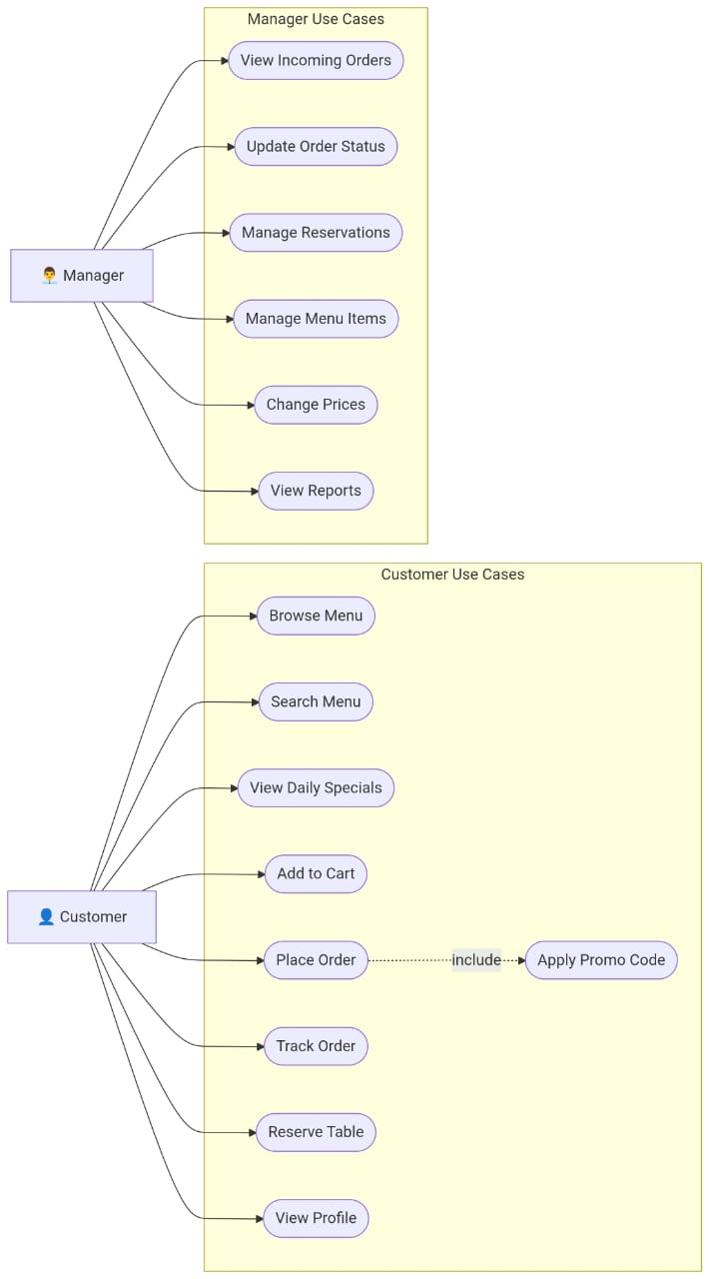
The Use Case Diagram shows how the two main users, Customer and Manager, interact with the Restaurant App.
- Customers can browse and search the menu, add items to the cart, place and track orders, and reserve tables.
- Managers can manage orders, reservations, menu items, prices, and reports.
2. Class Diagram
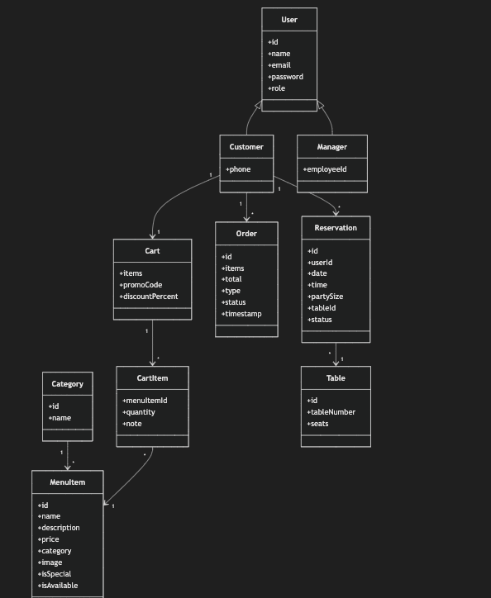
The Class Diagram shows the main data structures used by the Restaurant App and how they are related. It includes users, menu categories, menu items, carts, orders, reservations, and tables. These classes represent the client-side data that the frontend uses to provide the required restaurant features.
3. Sequence Diagram:
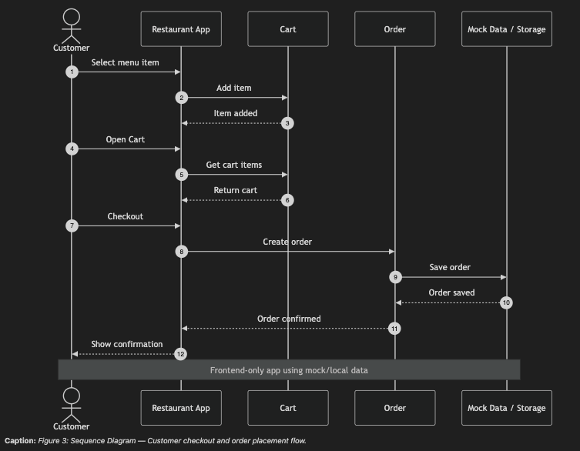
The Sequence Diagram shows the steps involved when a customer places an order. The customer selects an item, adds it to the cart, proceeds to checkout, and places the order. The app saves the order in mock or local data and then displays an order confirmation.

4. State Machine Diagram:
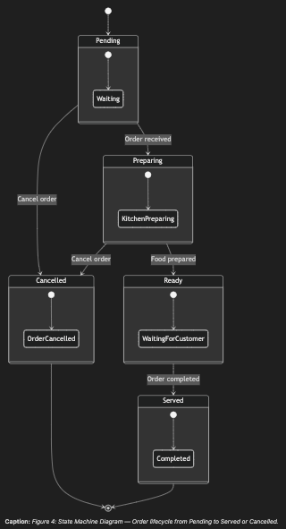
The State Machine Diagram shows the different states of a customer's order. After an order is received, it moves from Pending to Preparing, then Ready, and finally Served. An order can also be cancelled before completion.
5. Component Diagram:
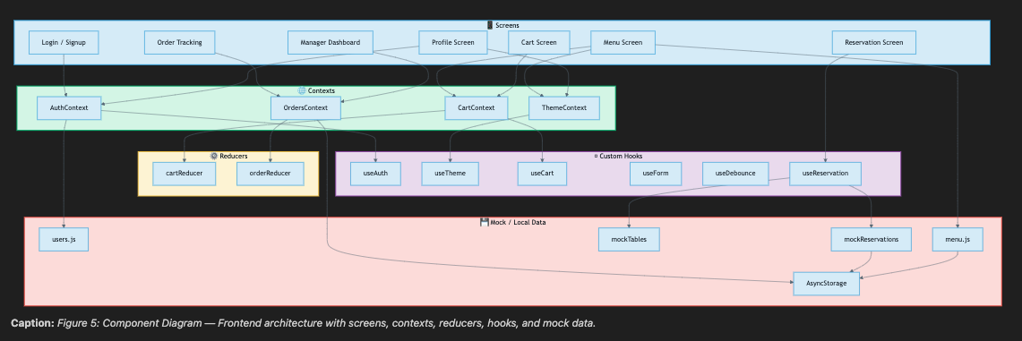
The Component Diagram shows the main frontend parts of the Restaurant App and how they work together. It includes screens, contexts, reducers, custom hooks, and mock/local data. These components are connected to manage authentication, themes, cart data, orders, reservations, and menu information without requiring a backend.

7. MVP Frontend Development

7.1 Login and Signup:
Purpose: Allow customers and managers to enter or create an account.

Main UI: Email, password, name, confirm password, role selector, login/signup buttons.

Hook: useState

7.2 Menu Browsing:
Purpose: Allow customers to browse restaurant food.

Main UI: Categories, food cards, prices, images, availability, Daily Special badge.

Hooks: useState, useEffect

7.3 Search and Scroll Controls:
Purpose: Help customers quickly find food and navigate a long menu.

Main UI: Search bar, suggestions, clear button, Back to Top button.

Hook: useRef

7.4 Profile and Theme:
Purpose: Show user information and allow the customer to change the app theme.

Main UI: Name, email, role, light/dark switch, logout.

Hooks: useContext, custom hooks

7.5 Cart:
Purpose: Allow customers to review and modify their selected food.

Main UI: Items, quantities, notes, remove buttons, promo code.

Hook: useReducer

7.6 Order Summary:
Purpose: Show the complete cost before an order is placed.

Main UI: Subtotal, service charge, tax, discount, grand total.

Hooks: useMemo, useCallback

7.7 Table Reservation:
Purpose: Allow customers to reserve an available table.

Main UI: Date, time, party size, table availability, contact information, confirmation.

Hooks: Custom hooks

7.8 Order Tracking and Manager Dashboard:
Purpose: Allow customers to track orders and managers to manage restaurant operations.

Customer: Track order progress.

Manager: Manage orders, reservations, menu items, prices, and availability.

Hooks: useEffect, useReducer, and the other hooks used throughout the application.

